Product specification

Model: YQW032A/YTW032A

File No：xx-xxxxxx
Version: V1.0

Date | Version | Change history | Author | Approve
2016.12.07 | V1.0

Best for T6cm+ huge light box lighting

YQW032A/YTW032A

1. Features

- Constant Current Technology (CCT)，
- The Aluminum plate for heat dissipation
- Energy saving，Environment friendly
- Long life span
2. Applications
- Commercial standing lighting
- Light box lighting
- Logo lighting
- Line/shape lighting

3. Dimensions
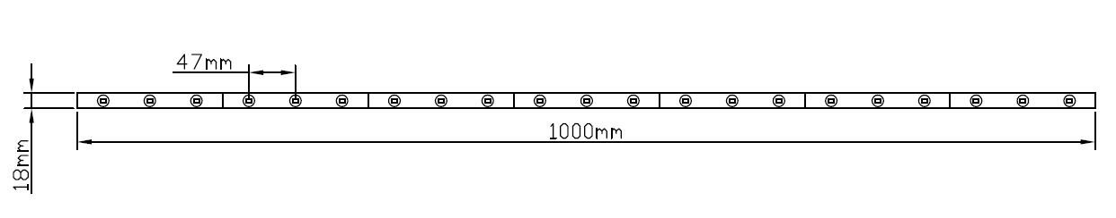
Remark：The pitch of the light-bar is variable.
4. Environmental and Application Conditions
Ambient temperature range (TA on free air) | -25…..+55℃
Operating (case) temperature range (TC) | -25…..+55℃
Storage temperature range | -25…..+65℃
IP rating | IP62

5. Electrical parameters
Supply voltage range | 12 VDC
Supply Current range (per module) | 420mA/1.25A
Power range (per module) | 5W/15W
ESD protection | Contact 4KV, Air 8KV

6. Optical parameters (module base)
Part No. | Color Range |  |  | Flux Range |  | Beam angle
Part No. | Min. CCT or wavelength | Typ. CCT or wavelength | Max. CCT or wavelength | Min. Lumen | Typ. Lumen | Beam angle
YQW032A | 6000 K | 6500 K | 7000k | 450 lm | 460 lm | 170º
YTW032A | 6000 K | 6500 K | 7000k | 1400lm | 1500lm | 170º

7. LED module light distribution graph
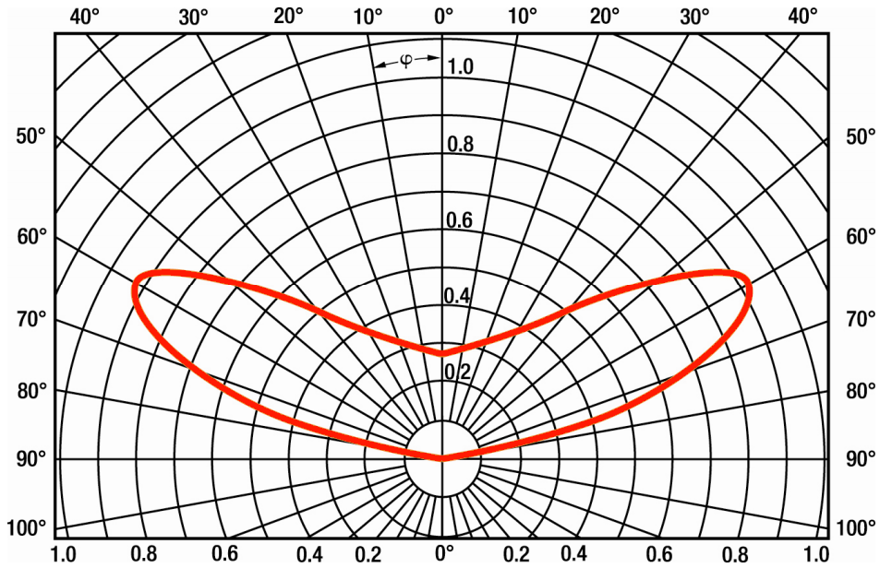

8. Attention
- Max. number of modules of one chain is 1pcs from power supplier to single end.
- The given illuminance parameters ensure illuminance on the surface. Depending on the type of material used for channel letters or lighting boxed,the parameters can change.More brightness is obtained if distances between LED modules are reduced.
- The LED module itself and all its components may not be mechanical stressed.
- Please ensure that the power supply is adequate power to operate the total load. Only qualified personnel should be allowed to perform installations.
- The design of the housing should be according to the IP standards in the application.
- If surge protection structure not within power supplier, a lightening protector should be needed additionally.

